Empowering Women: A Creative Approach to Integrated Safety with Machine Learning Algorithms

In propose work author employing various number of algorithms such as Machine Learning, Navigation and panic detection to ensure women safety. Using ML algorithms women can know number of reported crimes in all parts of states. Using Panic module women can send emergency message to registered email id to seek help. Using Navigation module women can know locations of police station in their routes.

A user-friendly platform, the Integrated Women's Safety Application equips women with crucial safety features. In a single interface, it offers secure login, news notifications, emergency panic buttons, incident reporting, route routing with police station proximity, and heat map visualization. By placing a high priority on user privacy, it maintains confidentiality and provides easy access to help via the panic button. Situational awareness is improved by news notifications, and route navigation facilitates safe travel arrangements with law enforcement access. Reporting incidents enables authorities to respond quickly, and the heat map shows trends in safety. All things considered, it's a complete instrument that uses technology to successfully advance women's security and safety.

To train Neural Network we have used ‘women crime dataset’ which can be download from below KAGGLE URL

<https://www.kaggle.com/code/sujithcharan/women-safety/input>

To implement this project we have designed following modules

1. New user sign up: using this module women can sign up with the application and can give email id to which emergency messages has to forward.
2. User Login: using this module user can login to system
3. Train Neural Network: using this module will plot Neural Network training and validation accuracy graph upon completing training
4. Route Routing: using this module user can get route to different Police station nearer to enter location. (Note laptop won’t have GPS so we need to enter current location name)
5. Crime Predict on Women: using this module user can choose State Name and then application will predict Number of Crimes in that state
6. Panic: is user feel insecure so he will just tap this module and enter current location to send emergency email to registered email id
7. Heatmap: will plot women incident Heatmap graph from different states based on number of crimes detected.

SCREEN SHOTS

To run project install Python3.7.2 and then install all packages given in requirements.txt file. Install MYSQL database and then open MYSQL console and then copy content from ‘database.txt’ file and paste in MYSQL console to create database.

Now double click on ‘runWebServer.bat’ file to start python server and then will get below page

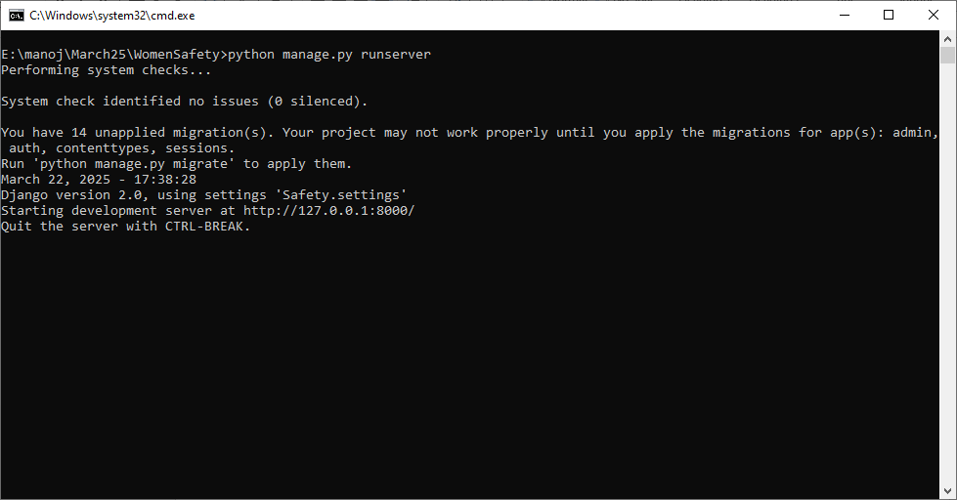

In above screen python web server started and now open browser and enter URL as <http://127.0.0.1:8000/index.html>’ and then press enter key to get below page



In above screen click on ‘New User Sign up Here’ link to get below page

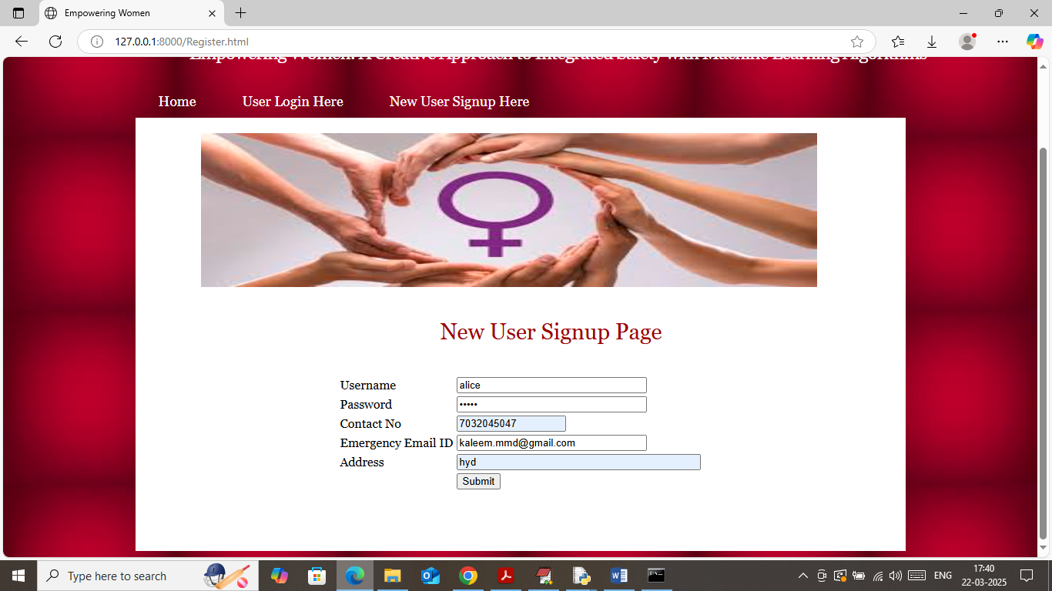

In above screen user is entering sign up details and then enter valid email to received email messages and then press button to get below page

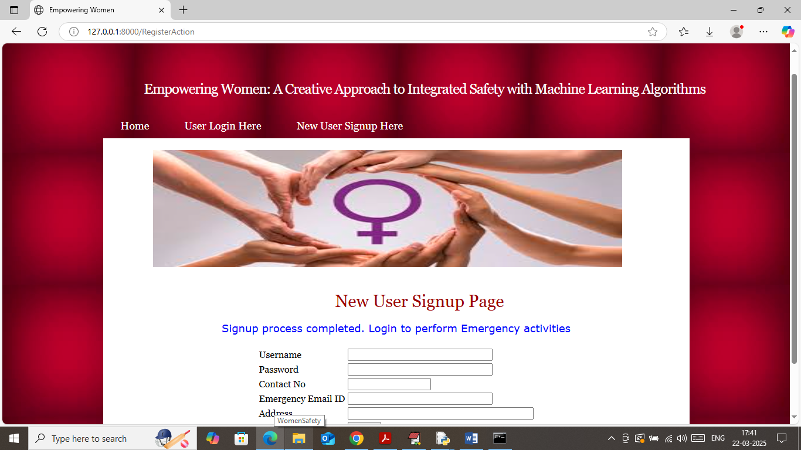

In above screen user sign up completed and now click on ‘User Login’ link to get below page

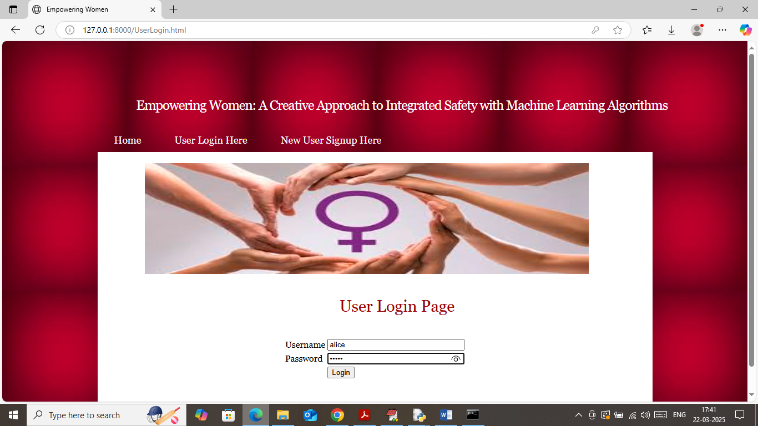

In above screen user is login and after login will get below page



In above screen click on ‘Train Neural Network’ link to train algorithm and then will get below page

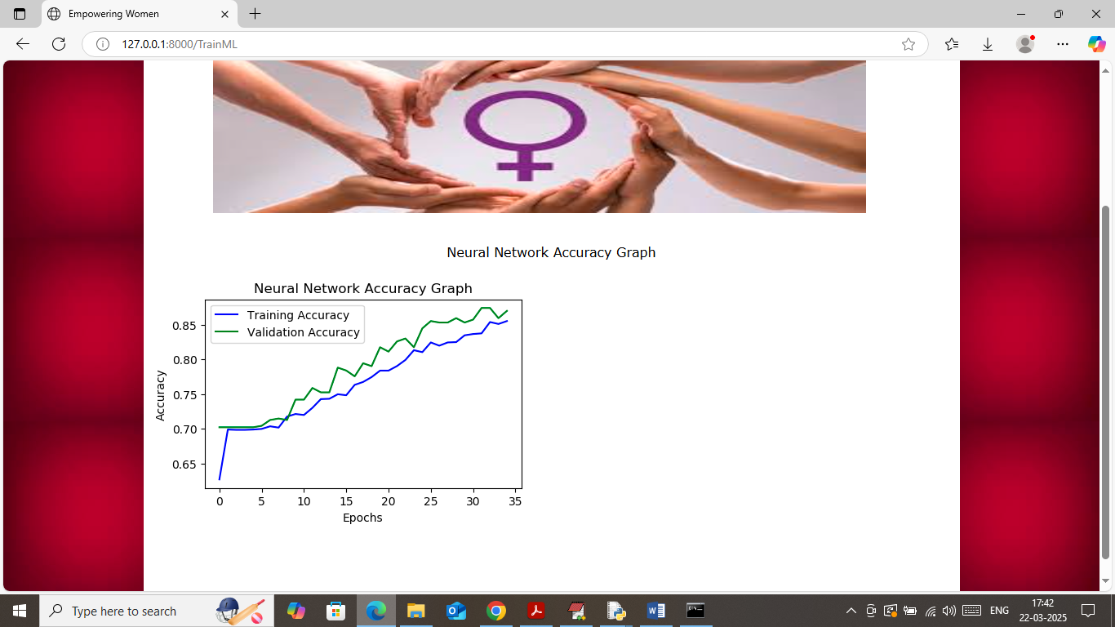

In above graph x-axis represents number of training epoch and y-axis represents accuracy and then green line represents training accuracy and blue line represents validation accuracy. In above graph can with each increasing epoch accuracy got increased and reached closer to 1. Now click on ‘Route Routing’ link to get below page

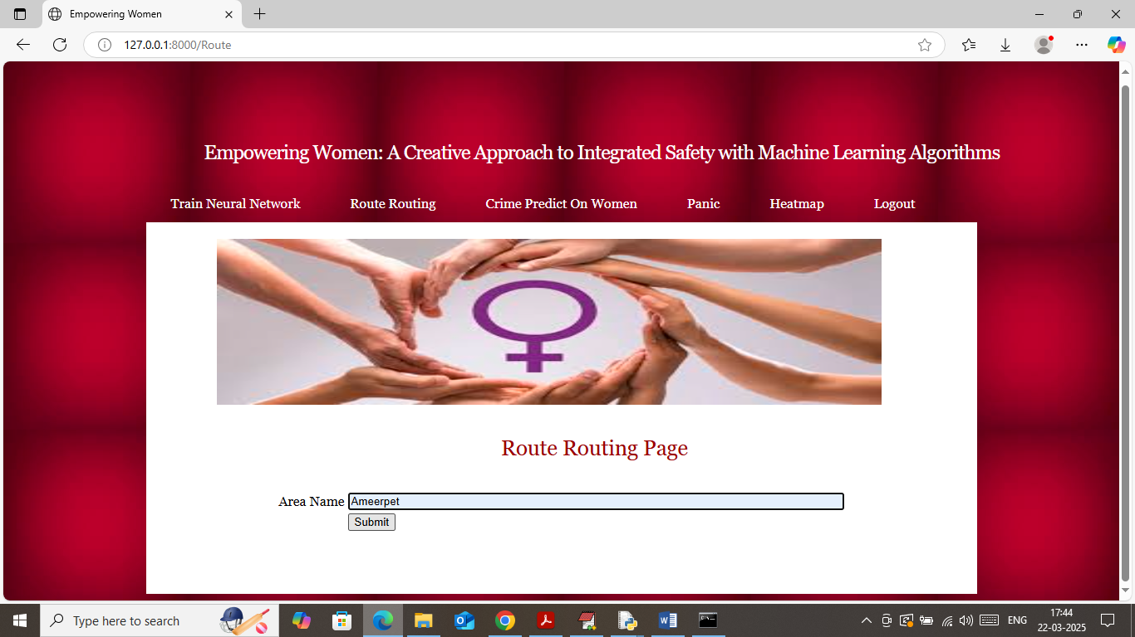

In above screen enter current location name to get all nearest police station routes

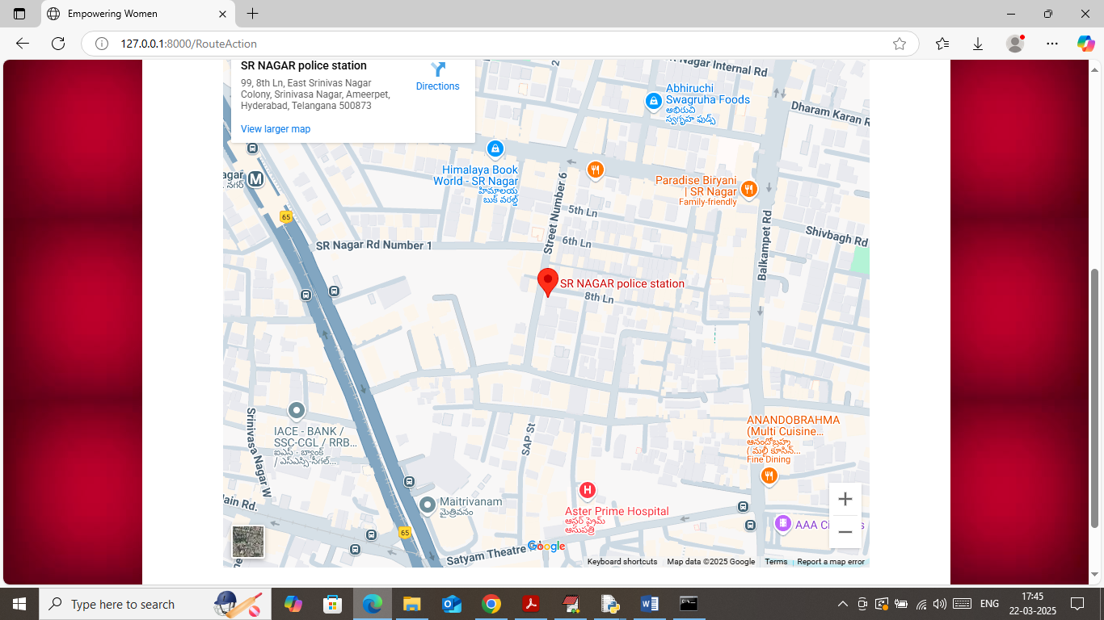

In above screen with balloon icon can see all nearest police station routes in map. Now click on ‘Crime Predict on Women’ link to get below page

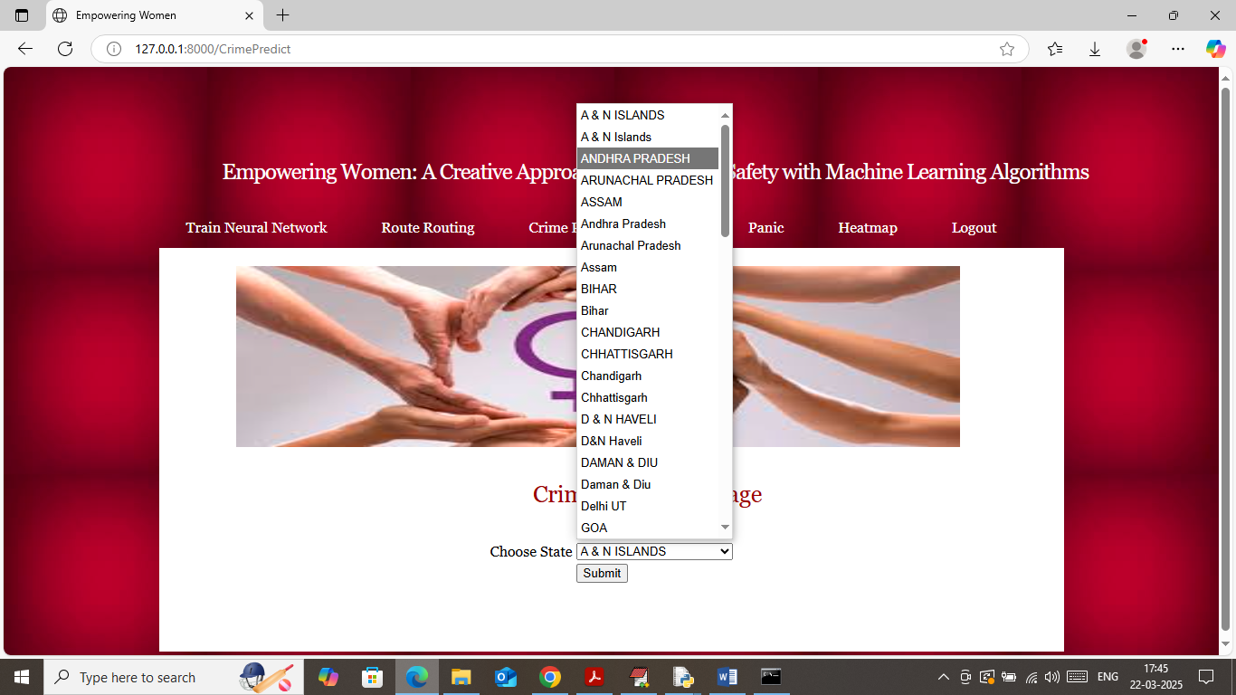

In above screen select state name and then press button to get below page



In above screen for selected state number of crimes predicted in a year is 871. Now click on ‘Panic’ link to get below page

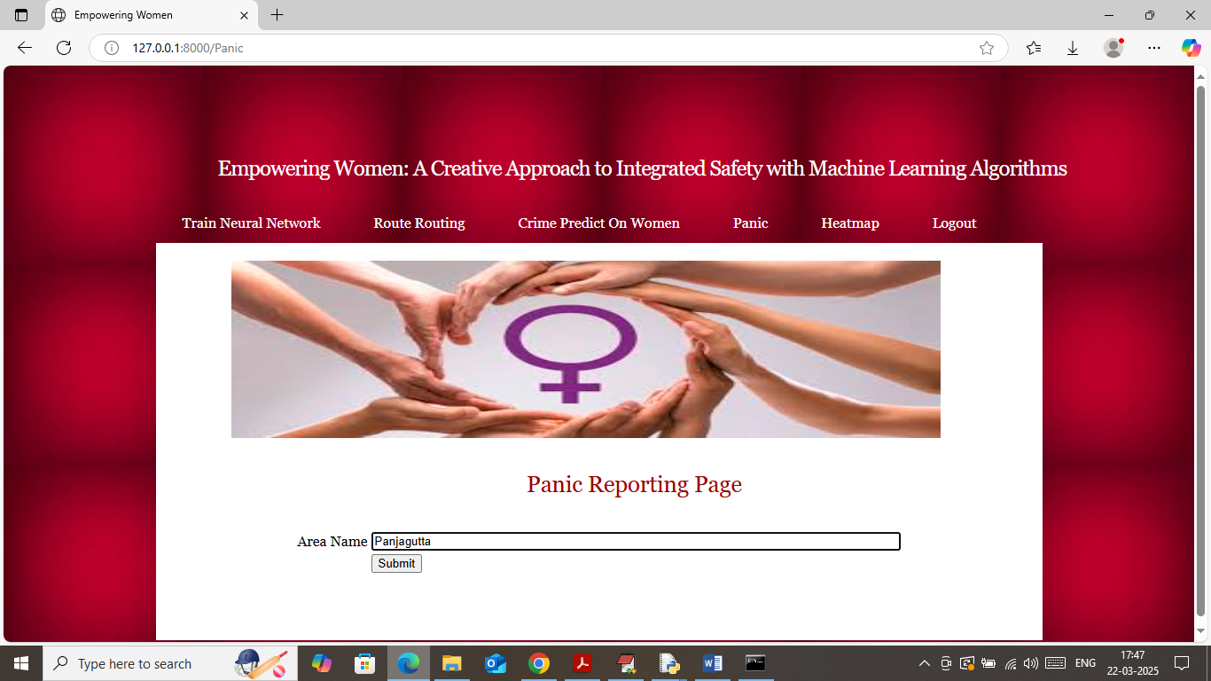

In above screen enter current location name and then press button to send emergency email message to registered email id like below page

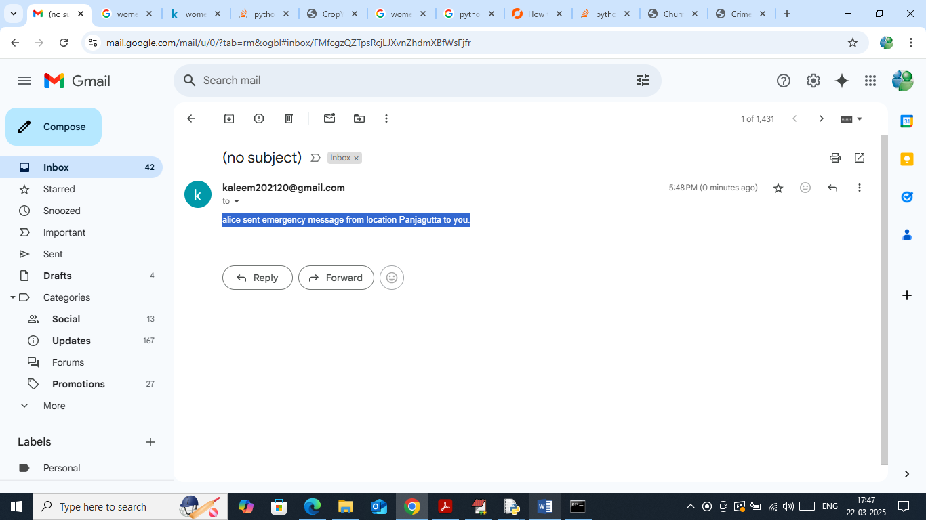

In above screen received emergency email message and now click on ‘Heatmap’ link to view most number of crimes committed incidents on women using Heatmap

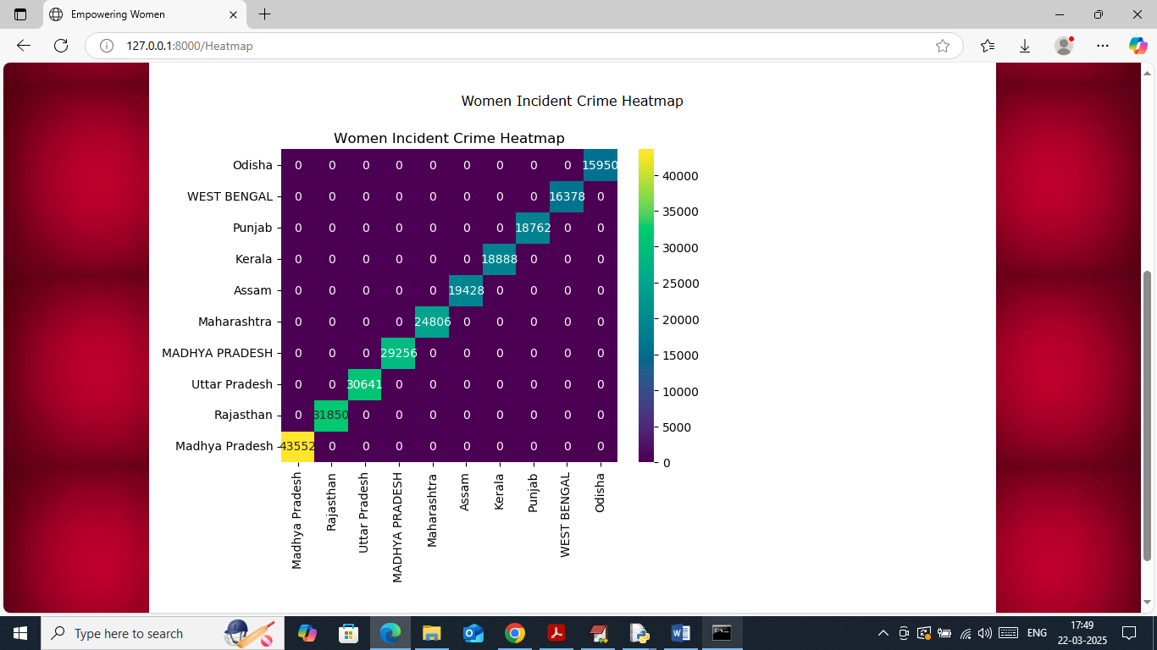

In above screen x and y contains state name and then boxes nearer to that state represents number of crime incidents on women.

Similarly by following above screens you can run all modules on women safety